SELECT * FROM pelanggan WHERE id = 15;

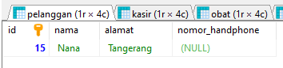

SELECT * FROM kasir WHERE id = 10;

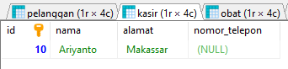

SELECT * FROM obat WHERE id = 7;

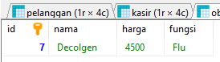

SELECT * FROM stok WHERE id = 5;

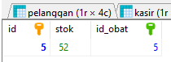

SELECT * FROM transaksi WHERE id = 3;

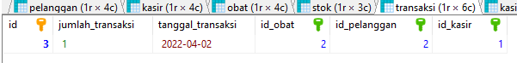

SELECT * FROM kasir WHERE id BETWEEN 11 AND 15;

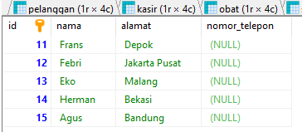

SELECT * FROM pelanggan WHERE id BETWEEN 6 AND 10;

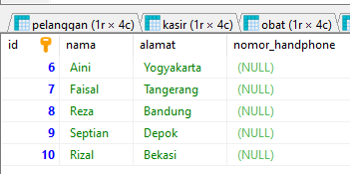

SELECT * FROM pelanggan ORDER BY alamat;

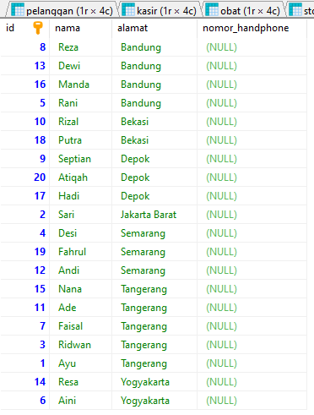

SELECT * FROM kasir ORDER BY nama;

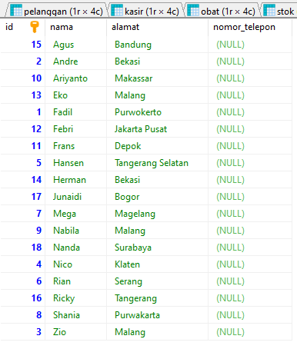

SELECT * FROM transaksi ORDER BY tanggal_transaksi;

